Task 2.2: Adding Style to the Webpages Using CSS
Name: Draven Chen
Date: 06/13/2026

Overview
In this Touchstone task, I created an external CSS file (styles.css) to add styling and colors to the HTML pages for Book Haven Bookstore. The component colors, font colors, and typography styling are consistent with my choices in Task 1 and are appropriate according to the client description provided in the Client Scenario and Criteria document. The majority of the styling was incorporated using the external CSS file, with all four HTML pages (index.html, gallery.html, about.html, and events.html) linking to the same stylesheet. All color choices align with Color Palette 1, featuring Inkwell Blue, Aged Gold, Parchment White, Dusty Rose, and Intensity Indigo as the primary palette colors.

Instructions
Provide your responses in the following table.

Rendered Homepage Screenshot
Hint: Provide the screenshot for the rendered Homepage.
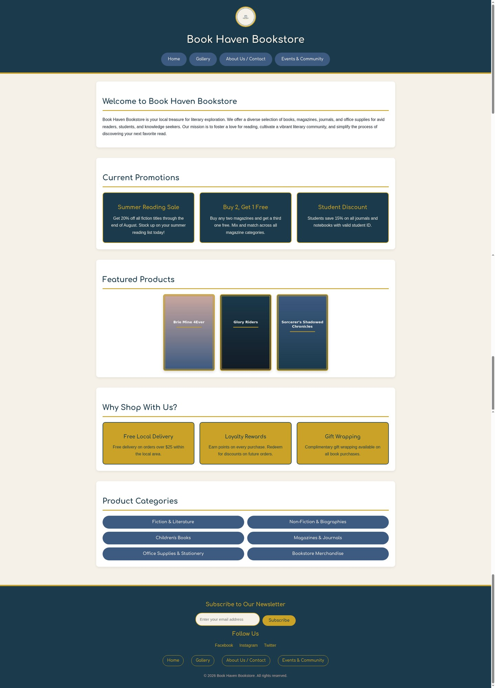

Homepage Analysis
Hint: Provide a brief description about the rationale of the CSS styling in the Homepage.
The Homepage (index.html) was styled to create a welcoming and visually engaging landing page that immediately communicates the Book Haven Bookstore brand identity.
• Header Section: The header uses Inkwell Blue (#1B3A4B) as the background color with Parchment White (#F5F1E8) text to create a strong, professional first impression. The Aged Gold (#C9A227) accent border at the bottom of the header ties in with the bookstore's classic, elegant aesthetic. The logo is displayed with a circular gold border to draw attention to the brand identity.
• Navigation Bar: The navigation links are styled as pill-shaped buttons using Intensity Indigo (#3D5A80) with Parchment White text. On hover, they transition to Aged Gold with Inkwell Blue text, providing clear visual feedback to users. This styling makes the navigation intuitive and easy to identify.
• Promo Boxes: The three promotional boxes (Summer Reading Sale, Buy 2 Get 1 Free, Student Discount) are styled with Inkwell Blue backgrounds, gold borders, and Aged Gold headings. This creates a visually distinct call-to-action area that draws the user's eye to current offers. The hover effect with box shadows adds interactivity.
• Featured Products: The three book cover images are displayed in a horizontal row with gold borders and subtle hover scaling effects, making the products visually appealing and encouraging exploration.
• Shopping Perks: The "Why Shop With Us" section uses Aged Gold (#C9A227) background boxes with Inkwell Blue text, creating an energetic contrast that highlights the bookstore's value propositions. Each perk box has a dark border for definition.
• Product Categories: The categories are displayed as two-column rounded pill buttons in Intensity Indigo with Parchment White text, making them easy to scan and visually organized.
• Footer: The footer maintains consistency with the header using Inkwell Blue background, Aged Gold headings, and a gold accent border at the top. The newsletter subscription form is prominently displayed with styled input fields and a gold Subscribe button.

Rendered Gallery Page Screenshot
Hint: Provide the screenshot for the rendered Gallery page.
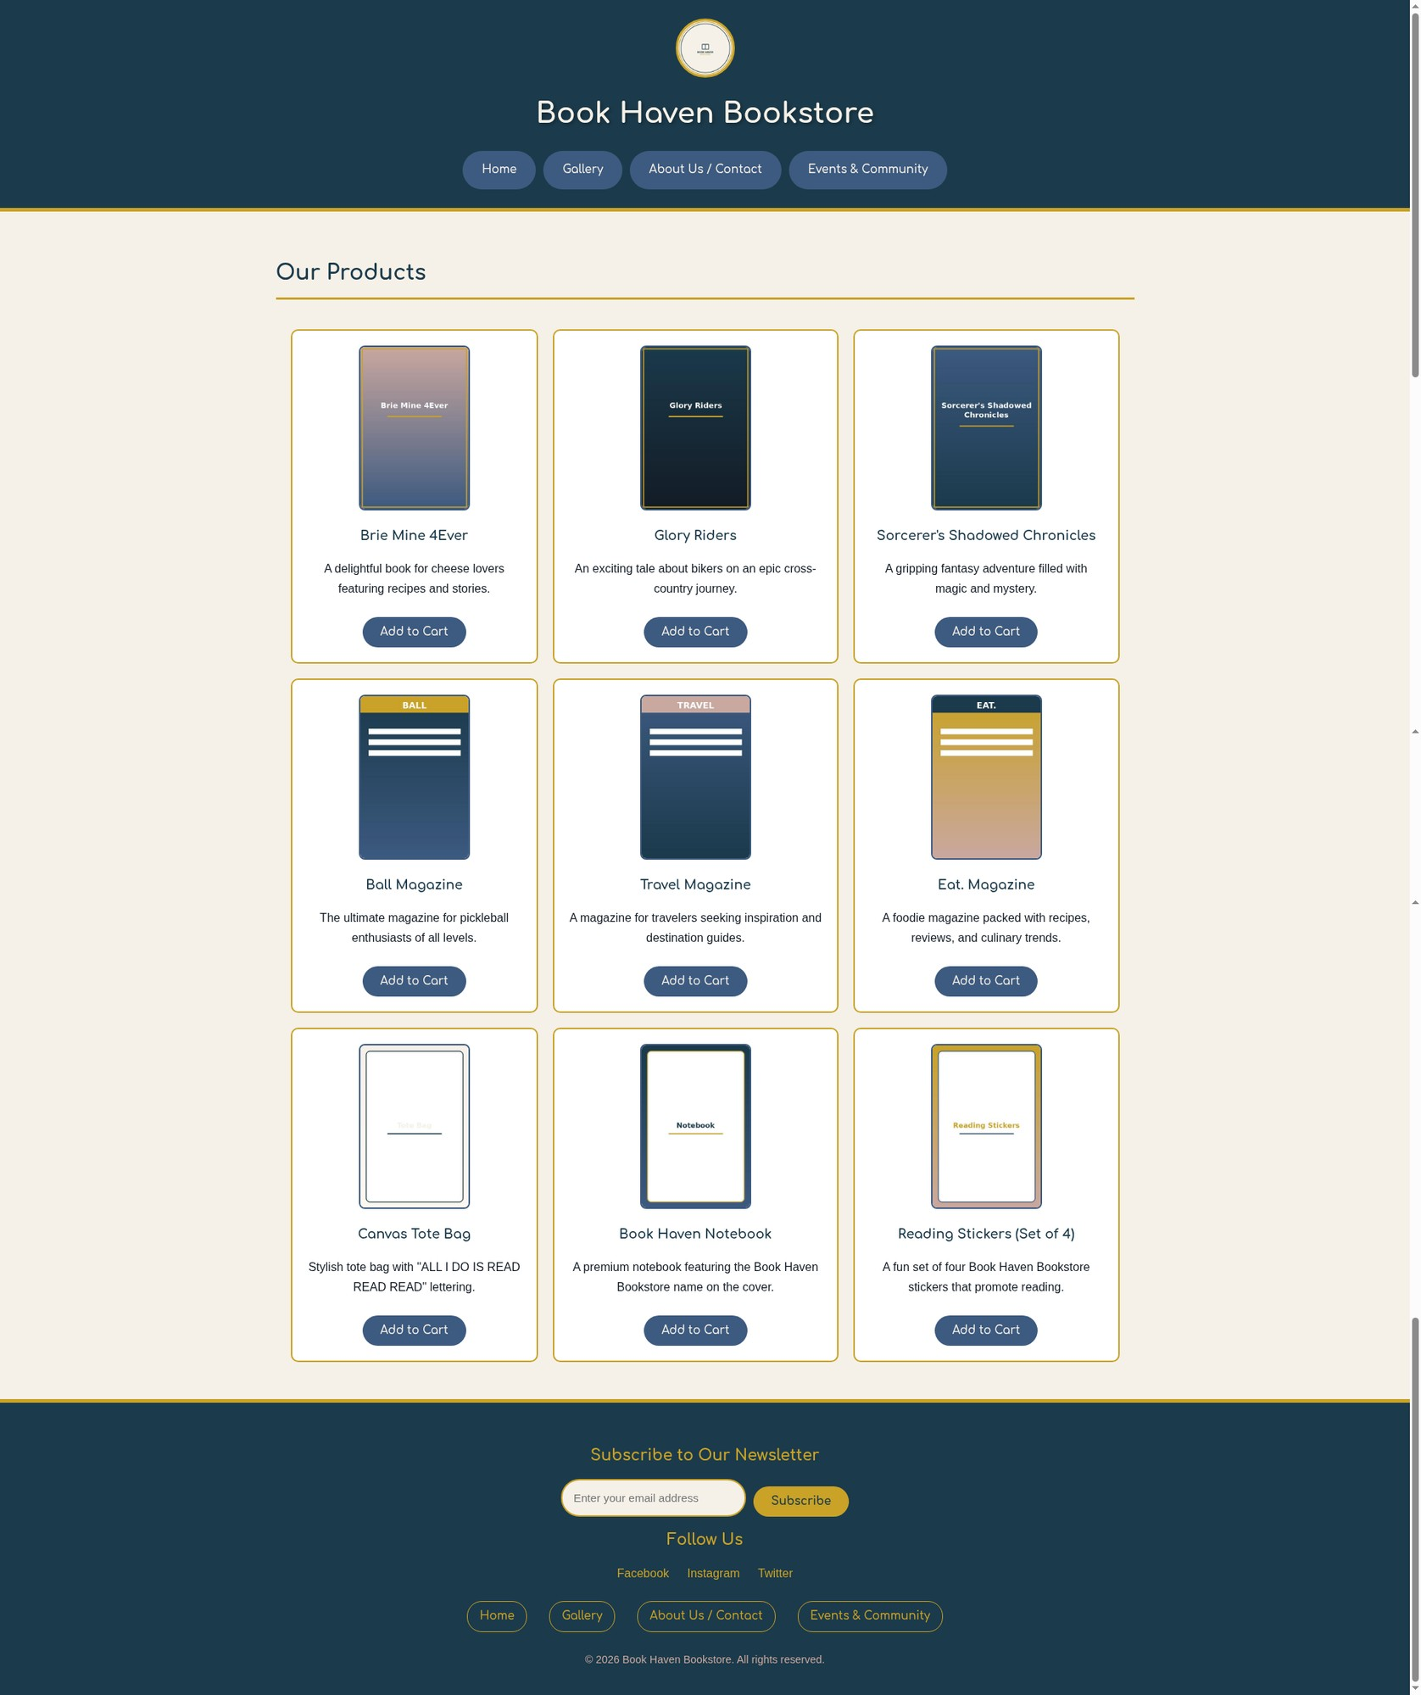

Gallery Page Analysis
Hint: Provide a brief description about the rationale of the CSS styling in the Gallery page.
The Gallery page (gallery.html) displays the bookstore's nine products in a 3x3 table layout, with each product card styled for visual appeal and usability.
• Product Table Layout: The 3x3 table uses generous border spacing (20px) between cells to prevent a cluttered appearance. Each cell has a white background with an Aged Gold (#C9A227) border and rounded corners (10px border-radius), creating a clean card-like appearance for each product.
• Product Cards: Each table cell contains the product image, product name in bold Intensity Indigo (#3D5A80) text using the Comfortaa typeface, a brief description in Bookish Black (#131C26), and an "Add to Cart" button. The cards have a subtle hover effect that lifts them slightly with an increased box shadow, providing satisfying tactile feedback to users.
• Product Images: All nine product images (three books, three magazines, and three merchandise items) are displayed with consistent sizing and styled with dark blue borders and rounded corners to maintain visual unity across the grid.
• Add to Cart Buttons: Each product card features an "Add to Cart" button styled with Intensity Indigo (#3D5A80) background and Parchment White text. The buttons use the Comfortaa typeface, have rounded pill shapes, and feature hover effects that change the background to Aged Gold with Inkwell Blue text while adding a subtle upward translation and shadow.
• Consistent Header and Footer: The Gallery page maintains the same header and footer styling as the Homepage, ensuring brand consistency and familiar navigation across all pages.

Rendered About Us/Contact Page Screenshot
Hint: Provide the screenshot for the rendered About Us/Contact page.
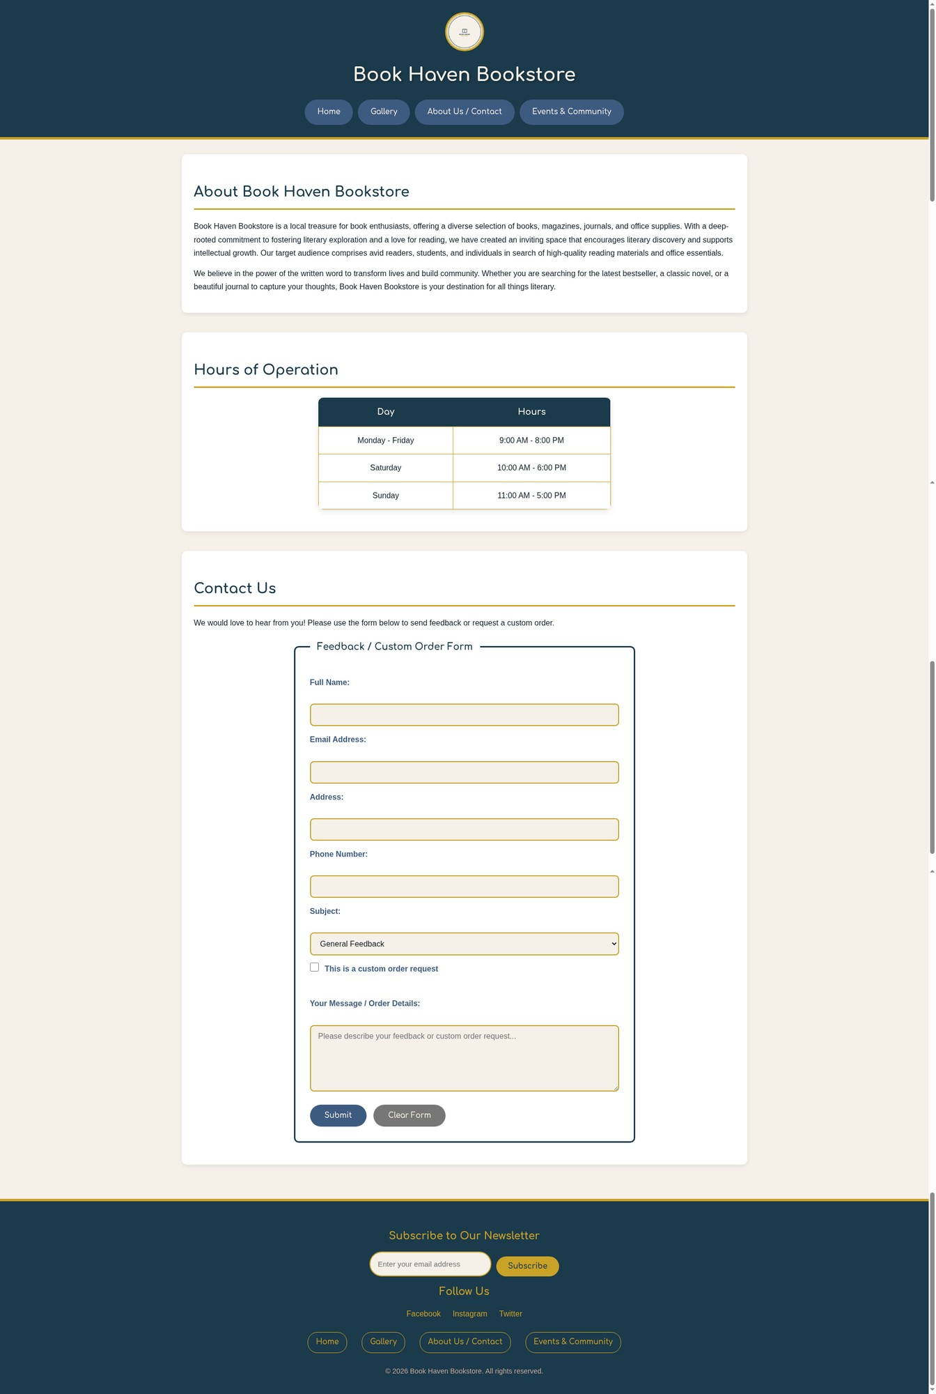

About Us/Contact Page Analysis
Hint: Provide a brief description about the rationale of the CSS styling in the About Us/Contact page.
The About Us / Contact page (about.html) was designed to present the bookstore's story in a readable, inviting format while providing a professional and accessible contact form.
• About Section: The "About Book Haven Bookstore" section uses a white background card with comfortable padding and the standard heading styling (Inkwell Blue with gold underline). The paragraph text uses Bookish Black (#131C26) on a clean white background to ensure maximum readability for longer content. The line height is set to 1.7 for comfortable reading.
• Business Hours Table: The hours of operation are displayed in a centered, styled table with a subtle box shadow. The table header uses Inkwell Blue (#1B3A4B) background with Parchment White text, while the data rows alternate between white and light cream backgrounds. The table has rounded corners (10px) and gold borders (#C9A227) that align with the overall palette. A hover effect changes the row background to Parchment White for better visual tracking.
• Contact Form: The "Feedback / Custom Order Form" is styled with a prominent fieldset using a 3px Inkwell Blue border and rounded corners. The legend uses the Comfortaa typeface in Inkwell Blue for clear identification. Each form field has:
- Bold Intensity Indigo (#3D5A80) labels for clear field identification
- Styled input fields with gold borders (#C9A227) and Parchment White backgrounds
- Focus states with dark blue borders and subtle glow shadows for accessibility
- Proper spacing between fields for visual clarity
• Form Buttons: The Submit button uses Intensity Indigo background with Parchment White text, while the Clear Form button is styled in gray (#777777) to visually differentiate its secondary function. Both buttons have hover effects with color transitions and subtle lift animations.
• Checkbox Styling: The custom order request checkbox uses the browser's default with accent-color set to Intensity Indigo for visual consistency with the form theme.

Rendered Custom Page Screenshot
Hint: Provide the screenshot for the rendered custom page.
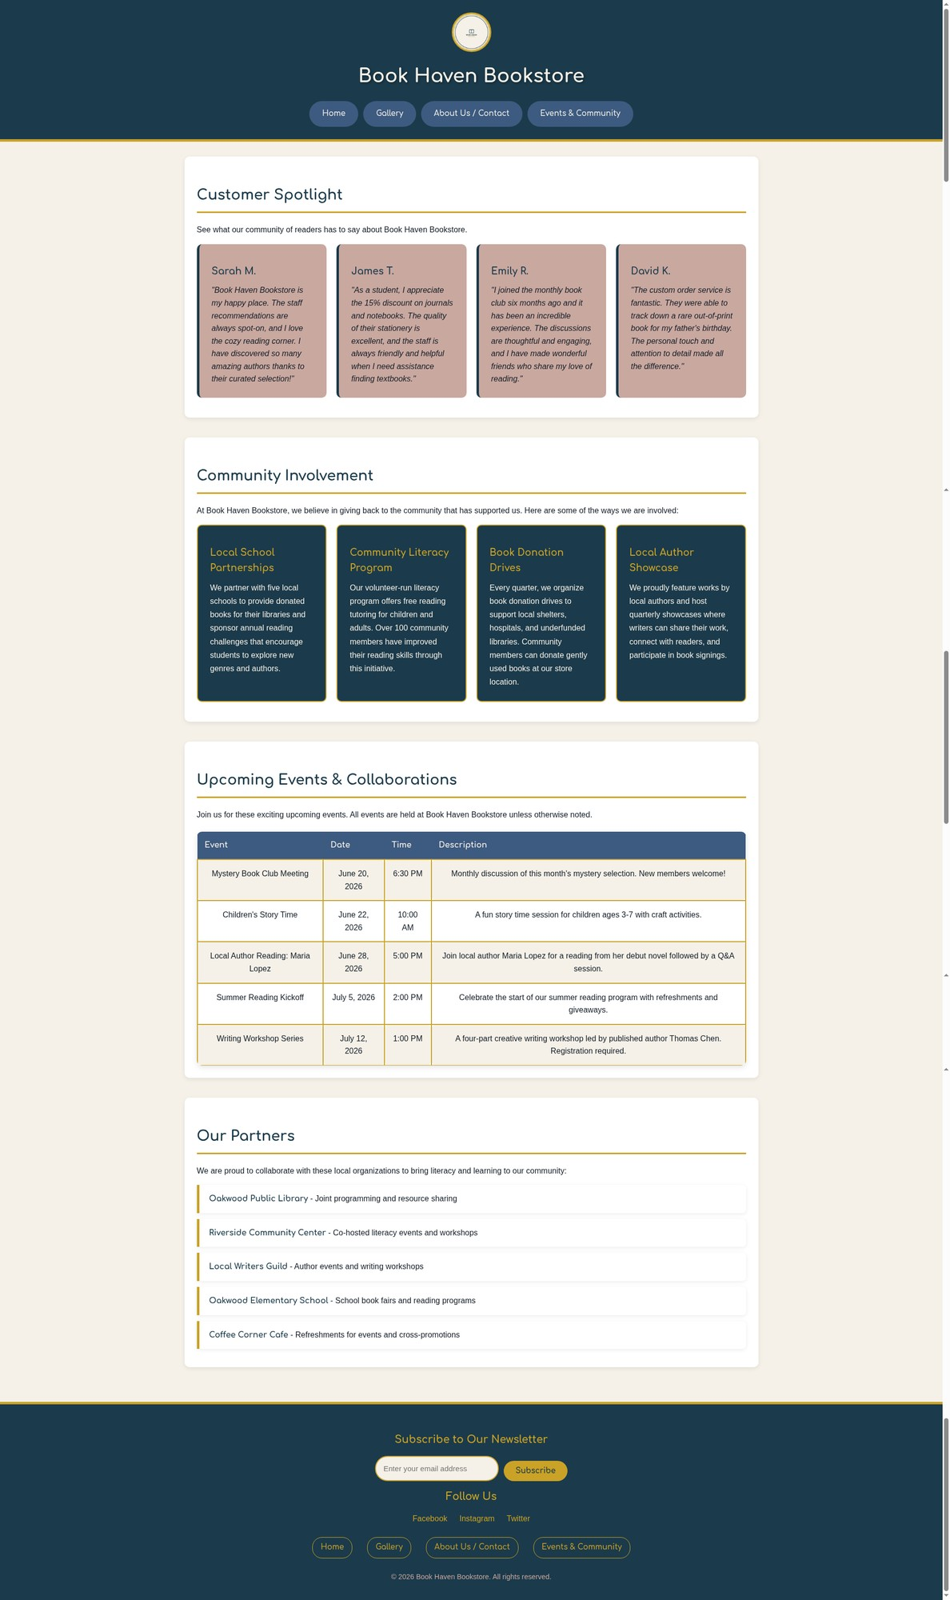

Custom Page Analysis
Hint: Provide a brief description about the rationale of the CSS styling in the custom page.
The custom fourth page (events.html) is the "Events & Community" page, styled to create a warm, community-focused atmosphere that encourages customer engagement.
• Customer Spotlight: The four customer testimonial boxes are styled with Dusty Rose (#C9A8A0) backgrounds and Inkwell Blue left borders. This color choice creates a warm, personal feeling appropriate for customer quotes. Each testimonial uses italic text for the quote content, with customer names in Comfortaa font. The boxes have a subtle hover lift effect and border-radius for a card-like appearance.
• Community Involvement: The four community initiative boxes use Inkwell Blue (#1B3A4B) backgrounds with Aged Gold (#C9A227) headings and Parchment White text. This darker styling distinguishes the community section from the testimonials while maintaining visual interest. The gold headings draw attention to each initiative's title. Each box has a gold border and rounded corners with a subtle hover translation effect.
• Upcoming Events Table: The events table features Intensity Indigo (#3D5A80) header row with Parchment White text. Data rows alternate between white and Parchment White backgrounds for easy scanning. The table has a box shadow, rounded corners, and gold row separators. A hover effect changes the row background to Dusty Rose, providing visual feedback when users browse events.
• Partners List: The five community partners are displayed in a styled list where each item has a white background with a left gold border and right-side rounded corners. Each item has a subtle box shadow. On hover, the left border changes to Inkwell Blue and the item shifts rightward slightly, creating an interactive feel. Partner names use bold Comfortaa font in Inkwell Blue for clear identification.
• Consistent Styling: Throughout the page, the same header, navigation, and footer styling from other pages is maintained, ensuring brand consistency and a unified user experience across the entire website.

Accessibility Analysis
Hint: Provide a brief description of how accessibility practices were followed on the website.
To provide an accessible experience to all users, I implemented the following accessibility practices throughout the Book Haven Bookstore website:
1. Color Contrast Compliance: All color combinations were tested using the WebAIM Color Contrast Checker (https://webaim.org/resources/contrastchecker/) to ensure they meet WCAG AA standards. The Bookish Black (#131C26) font color on Parchment White (#F5F1E8) backgrounds provides a contrast ratio of 15.4:1, far exceeding the required 4.5:1 for normal text. The navigation buttons with Parchment White text on Intensity Indigo (#3D5A80) backgrounds achieve a contrast ratio of 7.2:1, meeting the enhanced AAA standard for large text.
2. Semantic HTML Structure: All pages use proper semantic HTML5 elements including header, nav, main, section, footer, article, table, form, fieldset, and label elements. This ensures that screen readers can properly interpret and navigate the page structure. Heading hierarchy (h1 > h2 > h3) is maintained throughout all pages.
3. Keyboard Navigation: All interactive elements (links, buttons, form fields) have visible focus indicators using a 3px Aged Gold outline with 2px offset. This allows users who navigate by keyboard to clearly see which element has focus. The focus styles are defined for all interactive elements including links, buttons, inputs, selects, and textareas.
4. Alt Text for Images: All images on the website include descriptive alt text attributes. The logo has alt="Book Haven Bookstore Logo", book covers include the book title and "book cover" in the alt text, and product images describe the product being shown. This ensures that screen reader users can understand the visual content.
5. Form Accessibility: The contact form uses proper label elements associated with their corresponding input fields using the "for" attribute. Required fields are marked with the required attribute. The fieldset and legend elements group related form controls and provide context. Placeholder text provides additional guidance for input fields.
6. Reduced Motion Support: The CSS includes a @media (prefers-reduced-motion: reduce) query that removes all transitions and animations for users who have requested reduced motion in their system preferences. This ensures the website is comfortable to use for users with vestibular disorders.
7. High Contrast Mode: The CSS includes a @media (prefers-contrast: high) query that enhances contrast for users who need higher contrast. Backgrounds become pure white, text becomes pure black, and borders become more prominent to aid visibility.
8. Skip Navigation: A "skip to main content" link is included for screen reader users to bypass the navigation and jump directly to the main content area.

Responsive Web Design Analysis
Hint: Provide a brief description about how to adjust the website to be responsive for the mobile platform.
The Book Haven Bookstore website was designed with responsive web design principles using CSS media queries to ensure optimal viewing across desktop, tablet, and mobile devices.
1. Viewport Meta Tag: All HTML pages include the viewport meta tag in the head section: <meta name="viewport" content="width=device-width, initial-scale=1.0">. This tells the browser to set the viewport width to the device's width and sets the initial zoom level to 1.0, ensuring the page renders at its proper size without requiring horizontal scrolling.
2. Fluid Layout: The main content container uses max-width: 1200px with auto margins, allowing it to scale down on smaller screens while maintaining readable line lengths. All images use max-width: 100% with height: auto to prevent overflow on narrow viewports.
3. Media Query for Tablets (max-width: 768px):
- The navigation menu switches from horizontal to vertical stacking, with each link taking 90% of the width and centering for easy touch interaction.
- All flex containers (promo boxes, perk boxes, testimonial boxes, community boxes) stack vertically instead of side-by-side.
- Product categories switch from a two-column grid to a single column.
- Featured product images reduce to 80% width with a max-width of 300px.
- Tables become horizontally scrollable to prevent content from being squished.
- The footer newsletter form stacks vertically with full-width input fields.
4. Media Query for Mobile (max-width: 480px):
- Heading sizes are reduced (h1 to 1.5em, h2 to 1.3em) to fit smaller screens.
- Body font size reduces to 14px for better proportion on small displays.
- Business hours table padding and font size are reduced.
- Buttons maintain their pill shape but with slightly reduced padding.
5. Flexible Navigation: The navigation links use flex-wrap: wrap with a gap of 10px, allowing them to naturally wrap to multiple lines on narrower screens before the tablet breakpoint takes effect.
6. Print Styles: A print media query removes the header, footer, and navigation when printing, and simplifies the section styling with borders instead of shadows for better print output.
The responsive design ensures that Book Haven Bookstore customers can browse the website comfortably on any device, from large desktop monitors to small smartphone screens, without losing functionality or visual appeal.

Testing and Error Reporting
Hint: While writing and testing your code, record any errors, and state your approach to fixing the errors. Did the outcome look the way you expected? Did you find anything particularly difficult to accomplish?
During the development of the CSS stylesheet, I encountered the following issues:
Issue 1: Font Loading
Initially, the Comfortaa font from Google Fonts was not loading consistently across all pages. The headings would occasionally fall back to Arial instead of displaying Comfortaa.
Fix: I ensured that the Google Fonts link (<link href="https://fonts.googleapis.com/css2?family=Comfortaa:wght@400;600;700&display=swap" rel="stylesheet">) was placed in the head section of all four HTML pages before the link to the external CSS file. I also added font-display: swap to the @import rule and specified fallback fonts in the font-family declarations: font-family: 'Comfortaa', Arial, sans-serif. This ensures that if Comfortaa fails to load, the browser will use Arial as a fallback rather than a generic serif font.
Issue 2: Table Border Styling Conflict
The gallery page's 3x3 product table initially displayed with default browser borders in addition to my custom CSS borders, creating a double-border effect that looked unprofessional.
Fix: I explicitly set border="0" in the HTML table tag and relied entirely on the CSS border-spacing and border properties for styling. I also added border-collapse: separate to the CSS to prevent the browser from collapsing borders in unexpected ways.
Issue 3: Form Field Spacing
The contact form fields appeared too crowded together, making the form look cramped and harder to read.
Fix: I increased the margin-top for form labels to 15px and added more padding to input fields (12px 15px). I also added line breaks between form elements in the HTML structure and used the CSS adjacent sibling selector to ensure consistent spacing. The fieldset padding was increased to 30px to give the form more breathing room.
Issue 4: Mobile Navigation Stacking
On narrow viewports, the navigation links would not stack properly and would overflow the header container.
Fix: I added flex-direction: column and align-items: center to the nav element within the @media (max-width: 768px) media query. I also set each link to width: 90% and text-align: center to ensure they properly filled the available space on mobile devices while maintaining comfortable touch targets.
Issue 5: Footer Newsletter Input Width
The email input field in the footer newsletter form would become too narrow on tablet-sized screens, cutting off the placeholder text.
Fix: I added a media query for max-width: 768px that sets the footer input width to 90% and stacks the input and button vertically using flex-direction: column. This ensures the email field remains usable on all screen sizes.
Overall Outcome:
The final outcome closely matched my design vision from Task 1. The color palette creates the warm, literary atmosphere I intended, and the consistent styling across all four pages provides a cohesive user experience. The most challenging aspect was ensuring that the table-based gallery layout remained visually appealing and responsive, as tables can be difficult to style for mobile viewports. The hover effects and transitions add a polished feel without overwhelming the content.

Summary of CSS Styling Approach
External CSS File: styles.css
The majority of styling for the Book Haven Bookstore website is incorporated through a single external CSS file named styles.css. This approach ensures consistency across all four webpages and makes maintenance easier, as style changes only need to be made in one location.
Key CSS Features Implemented:
1. CSS Reset and Base Styles: A universal selector reset ensures consistent margins, padding, and box-sizing across all browsers. The body uses the selected typography (Arial, Calibri) and font color (Bookish Black #131C26) on a Parchment White background.
2. Color Palette Implementation: All five colors from Color Palette 1 (Inkwell Blue #1B3A4B, Aged Gold #C9A227, Parchment White #F5F1E8, Dusty Rose #C9A8A0, Intensity Indigo #3D5A80) are used throughout the website in a consistent manner.
3. Typography Hierarchy: The Comfortaa typeface is used for all headings (h1-h3) and navigation elements, while Arial and Calibri handle body text. This creates clear visual hierarchy while maintaining readability.
4. Box Model and Layout: CSS Flexbox is used extensively for the promo boxes, perk boxes, testimonial cards, and community boxes to create responsive, equal-height layouts. CSS Grid is used for the product categories list.
5. Visual Effects: Subtle transitions and hover effects are applied to navigation links, buttons, product cards, and list items. These effects use the transform and box-shadow properties with 0.3s ease timing.
6. Responsive Design: Two media queries handle tablet (768px) and mobile (480px) breakpoints, adjusting layouts from multi-column to single-column stacks.
7. Accessibility Features: Focus indicators, reduced motion support, high contrast mode support, and print styles ensure the website is usable by all users regardless of ability or device.
All four HTML pages link to this external stylesheet using: <link rel="stylesheet" href="styles.css"> placed in the head section along with the Google Fonts link for Comfortaa. No inline or internal CSS was needed, as all styling requirements were met through the external file.

